|  |
| --- |
| **Audit Name: Enterprise Person Hub (EPH)**  **Audit Number: 21115**  **Prepared By: Seun Mafi**  **Date Completed: 12/9/2021** |

|  |  |
| --- | --- |
| Control & Sample Information | |
| Control | B.1 – Completeness Validation Checks |
| Sample Number | 100% of failed batch jobs on 11/7/2021 were tested to determine adequacy and effectiveness of this control. |
| Supporting Documentation Received From | Nijesh Narayanankutty (Advisor, Production Support Services)  Nadesan Wijendran (Director, IT Systems) |
| Received Date | 11/1/2021, 11/18/2021, 11/19/2021, 12/8/2021 |
| Purpose of the Test | The purpose of this test is to ensure that data integrity checks occur between ESL and EPH (for real-time) to ensure data is transferred from one system to another for completeness. |
| Source Files | [B.1 – Completeness Validation Checks.msg](https://cvshealth.auditboardapp.com/download?file_id=144464&name=B.1%20-%20Completeness%20Validation%20Checks.msg)  [FW B.1 – Completeness Validation Checks.msg](https://cvshealth.auditboardapp.com/download?file_id=144465&name=FW%20B.1%20-%20Completeness%20Validation%20Checks.msg)  [EPH – Alert Listing.msg](https://cvshealth.auditboardapp.com/download?file_id=145906&name=EPH%20-%20Alert%20Listing.msg)  [EPH – Batch Job Failures (Follow-Up)](https://cvshealth.auditboardapp.com/download?file_id=148574&name=RE%20EPH%20-%20Batch%20Job%20Failures%20(Follow-Up).msg) |

**Attribute 1: Alerts are configured to indicate alert type being triggered and alert indicates the appropriate team to be notified for remediation.**

On 11/1/2021, IA received from Nadesan Wijendran (Director, IT Systems) a full listing of all the alerts generated from source system to EPH, the various teams responsible for each alert and the medium through which alert was received. Nadesan also included a full list of all the error codes generated by the EPH system ([EPH – Alert Listing.msg](https://cvshealth.auditboardapp.com/download?file_id=145906&name=EPH%20-%20Alert%20Listing.msg)).

*See evidence below:*

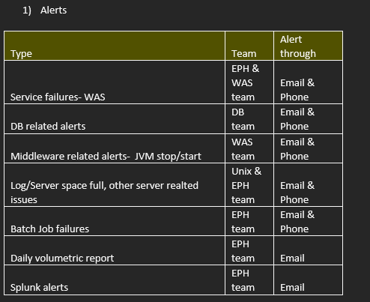

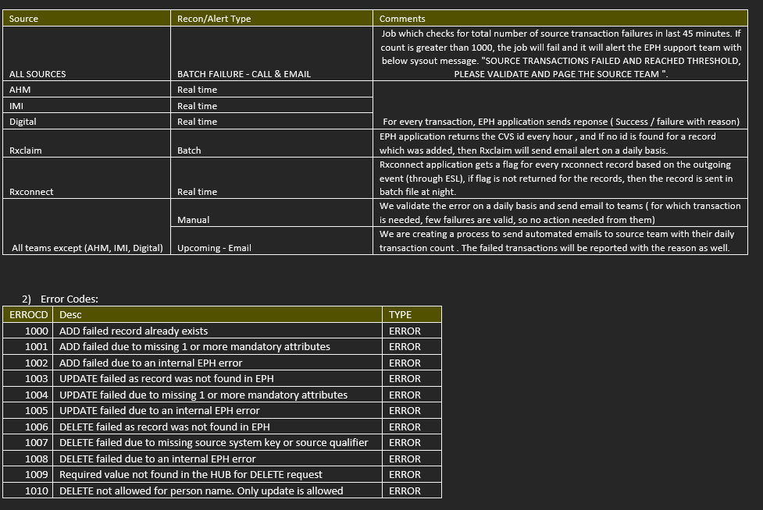

Batch job failure alerts are generated on a daily basis for timeouts and/or data ingestion failures from source system. Following this understanding, Nijesh provided a full list of all the batch failure alerts generated from source system on 11/7/2021. ([B.1 – Completeness Validation Checks.msg](https://cvshealth.auditboardapp.com/download?file_id=144464&name=B.1%20-%20Completeness%20Validation%20Checks.msg)) *See evidence below:*

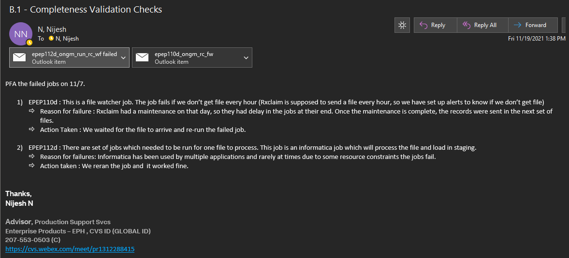

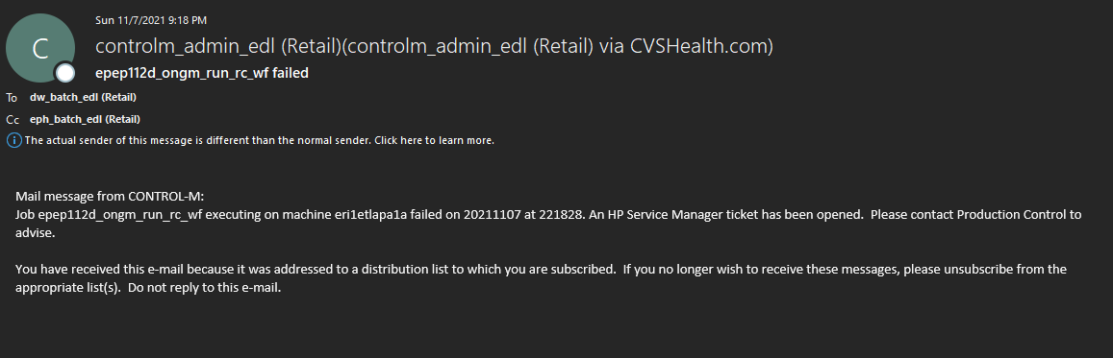

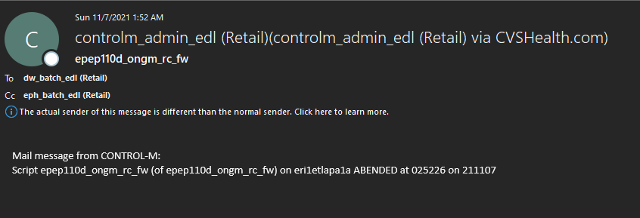

IA observed that two Batch jobs notably EPEP110d and EPEP112d failed, alerts were triggered via email from the system to the appropriate team to remediate failure. IA also noted that the failure ticket generated via email also included a description of what caused the failure.

IA gained assurance that batch job failure alerts are triggered and sent to appropriate team to be notified for remediation.

Attribute satisfied.

**Attribute 2: Alerts were followed through to remediation (Email communication or meetings)**

On 11/19/2021, Nijesh Narayanankutty (Advisor, Production Support Services) provided a full list of all the batch failure alerts generated from source system on 11/7/2021. ([B.1 – Completeness Validation Checks.msg](https://cvshealth.auditboardapp.com/download?file_id=144464&name=B.1%20-%20Completeness%20Validation%20Checks.msg)). IA got clarity that Batch job failure alerts are generated on a daily basis for timeouts and/or data ingestion failures from source system. Following this understanding, IA reviewed the data provided and noted that a remediation procedure was implemented for each batch job failure. In addition, IA also gained an understanding that the EPH support team followed through on ensuring that once a restart email is sent for failed batch jobs, the team checks if the job is successful; however, IA noted that the EPH support team does not get a notification for failed jobs that are remediated and becomes successfully ingested. *See evidence below:*

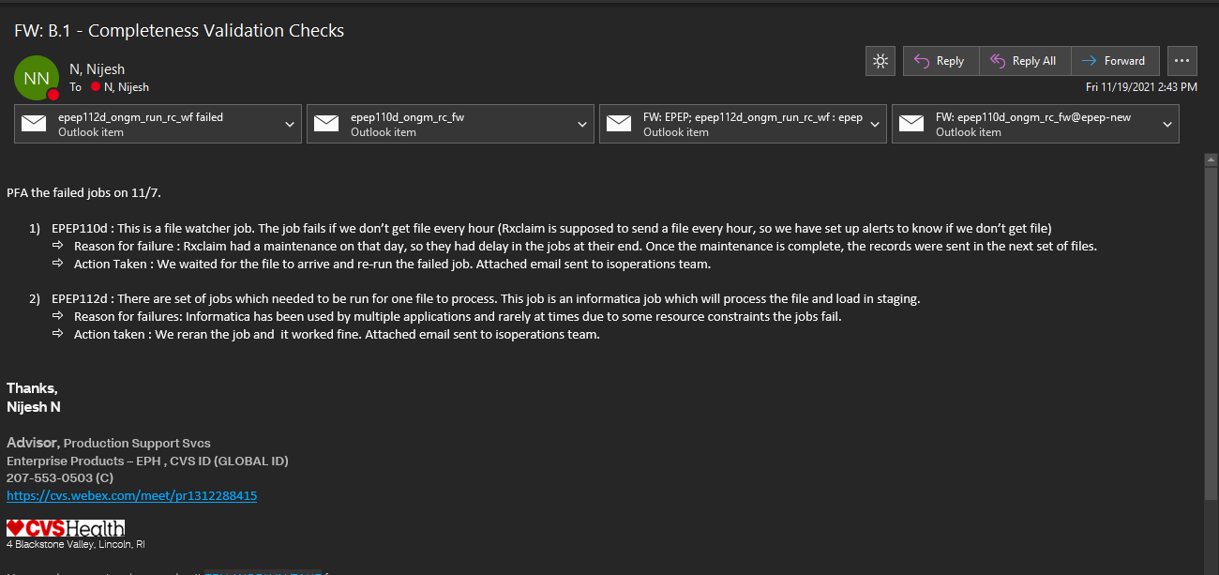

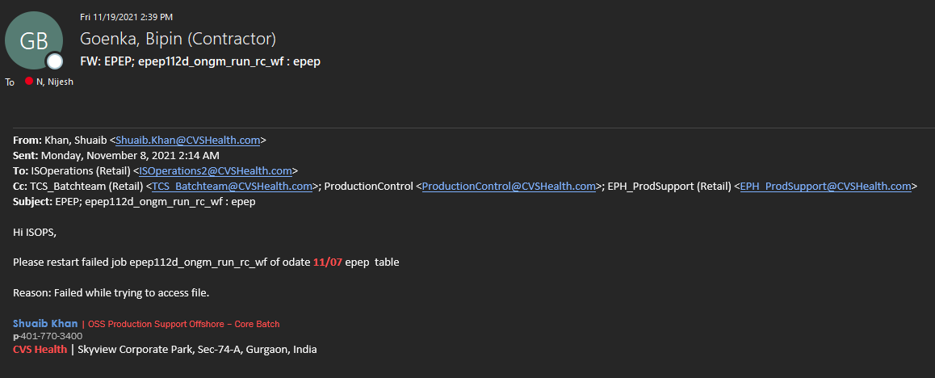

IA noted that a job restart request for failed batch job EPEP112d generated on 11/7/2021 was documented.

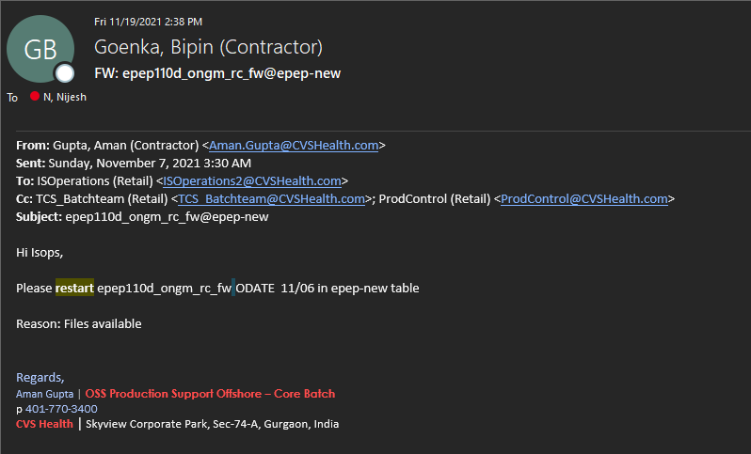

IA noted that a job restart request for failed batch job EPEP110d generated on 11/7/2021 was documented.

IA gained assurance that for both failed batch jobs EPEP110d and EPEP112d on 11/7/2021, the EPH support team received am email notification to restart both failed jobs and the team checked to ensure the job is successful. IA also observed that there is not a notification process in place for jobs that are re-run and become successfully ingested; however IA gained assurance that for any newly re-run failed batch jobs that are unsuccessful, a new batch job failure alert is generated. ([EPH – Batch Job Failures (Follow-Up)](https://cvshealth.auditboardapp.com/download?file_id=148574&name=RE%20EPH%20-%20Batch%20Job%20Failures%20(Follow-Up).msg)) *See evidence below:*

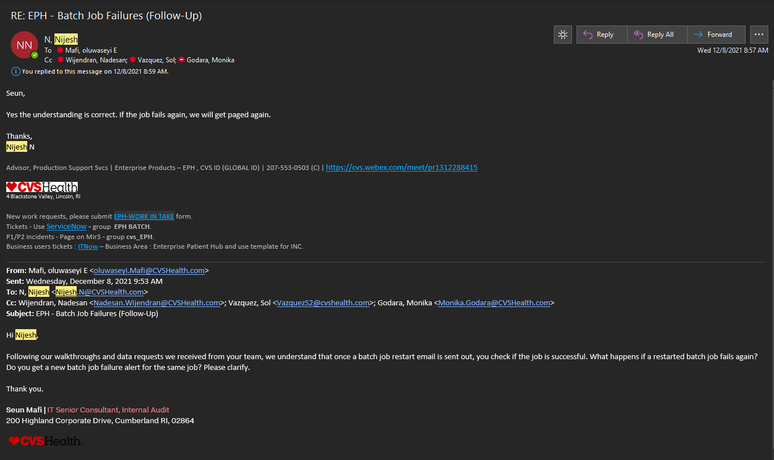

Attribute satisfied.

**Conclusion:**

After testing the evidence and artifacts provided, IA gained assurance that batch job failure alerts are triggered and sent to appropriate team to be notified for remediation and alerts are followed through till remediation is completed.